 | SAVEETHA SCHOOL OF ENGINEERING  SAVEETHA INSTITUTE OF MEDICAL AND TECHNICAL  SCIENCES  DEPARTMENT OF COMPUTER SCIENCE AND ENGINEERING |  |  |  | 
COURSE NAME: |  | Theory of Computation | COURSE CODE: | CSA13

COURSE OUTCOME COVERED
CO2: Design Finite Automata DFA, NFA, ε-NFA and demonstrate their equivalence for
recognizing regular languages. (BL:3)
Assessment Tool Weightage: 20%

QUESTIONS: 2  Duration: 1 Hour | Total Marks:50
Scenario Based

Code of Conduct:
I K.Sushruth(192411073) certify that this submission is my original work and that I have
adhered to the guidelines specified for this assessment.
I understand that any violation of academic integrity rules will result in disciplinary action.
Signature of the student: K.SUSHRUTH

QUESTION 1: SMART SECURITY SYSTEM USING REGULAR EXPRESSION

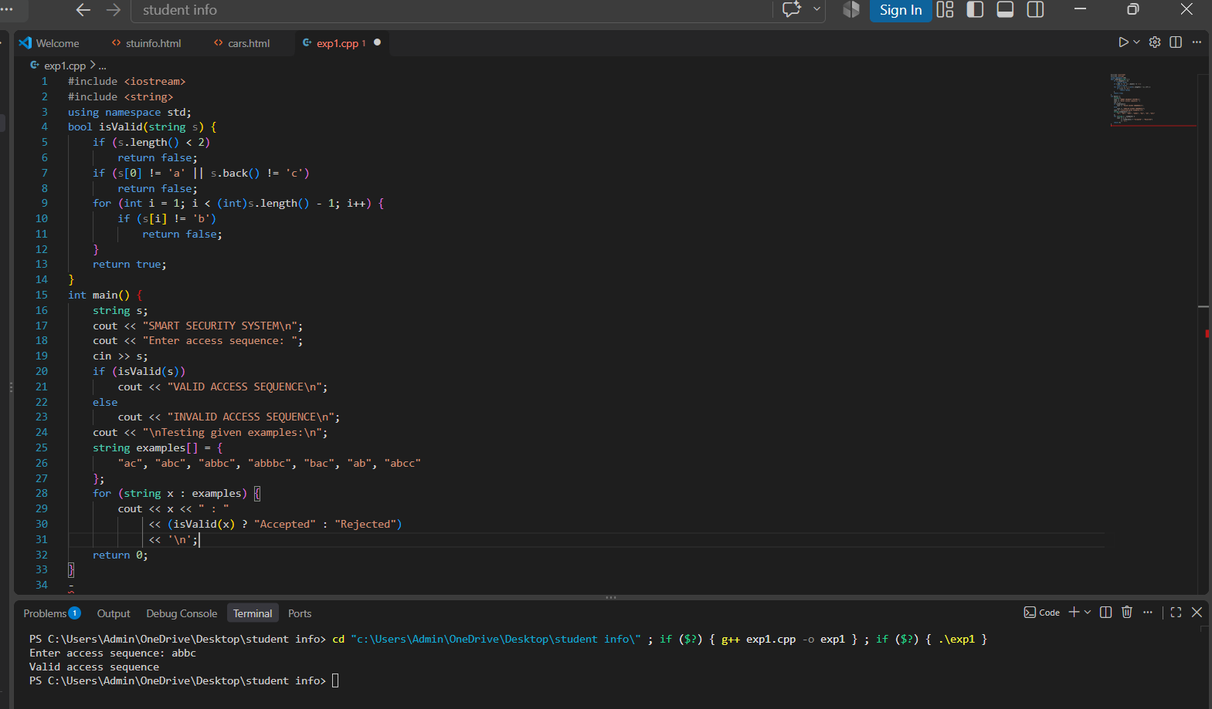

QUESTION 2: DFA MINIMIZATION FOR PIN PATTERN VALIDATION
